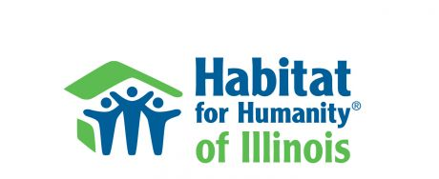

Habitat for Humanity of Illinois
Habitat Hero Nomination

Habitat for Humanity of Illinois is accepting nominations for 2022 Habitat Hero Awards. Habitat for Humanity affiliates in Illinois are invited to submit nominations to recognize volunteers who have made a positive impact through their involvement with the affiliate. Nominees can qualify in multiple categories and affiliates can submit multiple nominations.

All nomination forms are to be received by Friday, October 28, 2022. Awards will be presented at Habitat for Humanity Illinois Conference in Bloomington-Normal on Wednesday, November 9th. Nominators will be notified if their nominee is selected to receive an award.

Nominations can be emailed to conference@habitatillinois.org or mailed to Habitat Illinois, 5183 Harlem Rd. Suite 3, Loves Park, IL 61111.

Nominator Name: ________________________________________________________________________

Nominator Email: ________________________________________________________________________

HFH Affiliate: ________________________________________________________________________

Nominee Name: ________________________________________________________________________

Nominee Email: ________________________________________________________________________

Nominee Phone Number: ___________________________________________________________________

Award Category:
- Board Member
- Construction Volunteer
- Family Service Volunteer
- Fundraising Volunteer
- Marketing/Public Awareness Volunteer
- Pro-Bono Service Provider
- ReStore Volunteer
- Jim Carr Lifetime Achievement
Nominee’s role and contribution to Habitat for Humanity:
_________________________________________________________________________________________________

_________________________________________________________________________________________________

_________________________________________________________________________________________________

_________________________________________________________________________________________________

_________________________________________________________________________________________________

_________________________________________________________________________________________________

_________________________________________________________________________________________________

_________________________________________________________________________________________________

_________________________________________________________________________________________________

_________________________________________________________________________________________________

_________________________________________________________________________________________________

_________________________________________________________________________________________________

_________________________________________________________________________________________________

_________________________________________________________________________________________________

_________________________________________________________________________________________________

_________________________________________________________________________________________________

_________________________________________________________________________________________________

_________________________________________________________________________________________________

_________________________________________________________________________________________________

NOMINATIONS DUE OCTOBER 28, 2022.

Nominations can be emailed to conference@habitatillinois.org or mailed to Habitat Illinois, 5183 Harlem Rd. Suite 3, Loves Park, IL 61111.

